If the school is closed during bad weather, here are some activities you can do with your child:
Talk about the snow, listen to your child’s ideas about what is happening and why? (communication and language) | Build a snowman (expressive arts and design)  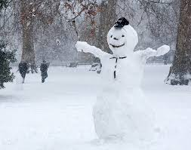
Make a snow angel (physical development)  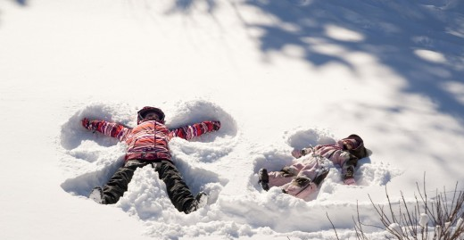 | Create a snowman in a bottle and watch him melt (understanding the world)  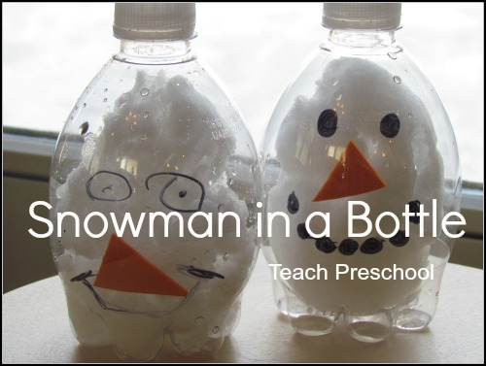
Mark making in flour/snow (literacy) | Cook some biscuits (mathematics)
Here are some websites with some other ideas:
http://www.parents.com/toddlers-preschoolers/activities/indoor/
http://theimaginationtree.com/2014/01/ultimate-play-activities-collection-rainy-day-fun-boredom-buster-activites.html
Remember to come and tell your key worker what you have been doing. Bring in any drawings, photos or notes for the children’s learning journals.

